ASKERNE 2023 RESERVE CHARDONNAY
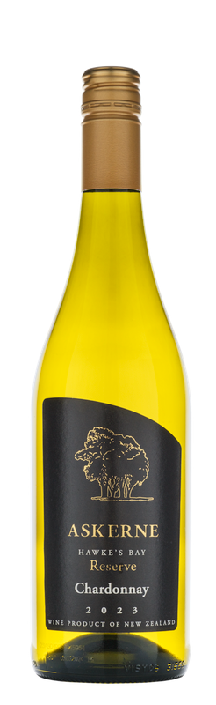

WINEMAKING NOTES
The fruit for this wine is a blend of Mendoza (50%), Clone 15 (45%) and Clone 548 (5%) grown on the sandy silt soils of the lower terrace of the Askerne vineyard. Hand-picked and whole bunch pressed, the juice was transferred to barrel for fermentation. The barrels were predominantly wild ferments and and completed 100% malolactic post ferment. The wine was subsequently aged for 10 months with lees stirring to add volume and complexity. The final blend has a 42% new French oak component, and 50% 2nd fill.
ANALYSIS
pH 3.38
TA 6.2/L
Alc 14.0%
RS 2.5g/L
TASTING NOTE
Powerful and fragrant, with sweet scented oak spice, baked peach and toasted brioche notes, balanced with concentrated lemon and lime aromas. The palate is full with an abundance of delicious citrus and stone-fruit flavours, interplaying beautifully with rich oak spice and juicy acidity.

AWARDS
94 Points Cameron Douglas
94 Points Wine Orbit
Gold - Dish Tasting Panel
Silver NZWIS
Silver Hawke’s Bay Wine Awards

